


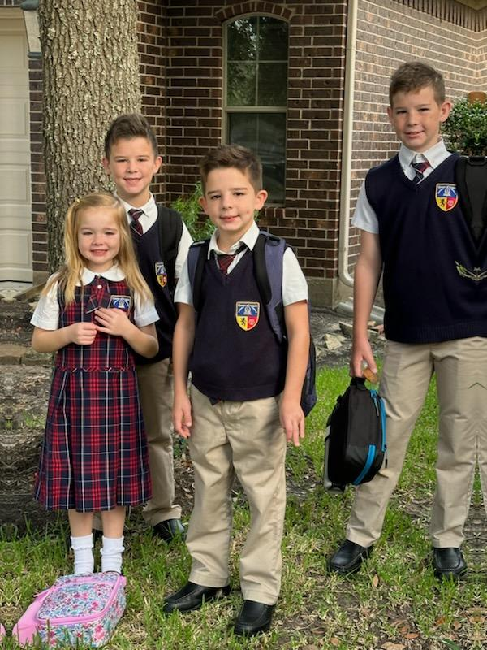
Type the kid's names here OR delete box prior to printing and have them handwrite on printed copies. Change the image to your kids by right-clicking on the photo box to right and selecting Change picture. Use picture format in top tools to adjust.

